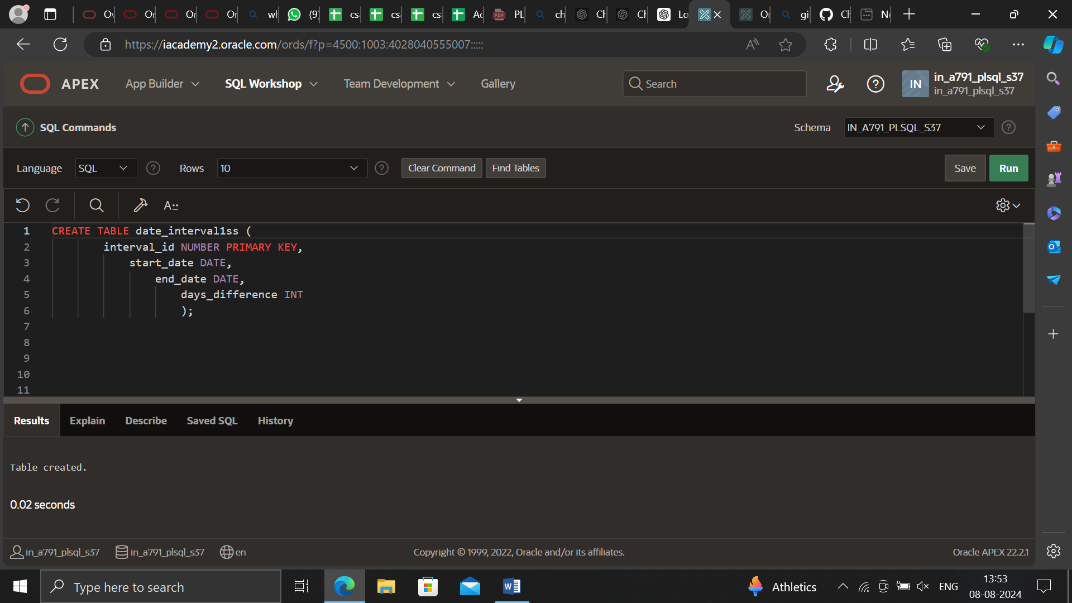

CREATE TABLE date_intervals (

interval_id NUMBER PRIMARY KEY,

start_date DATE,

end_date DATE,

days_difference INT

);

/

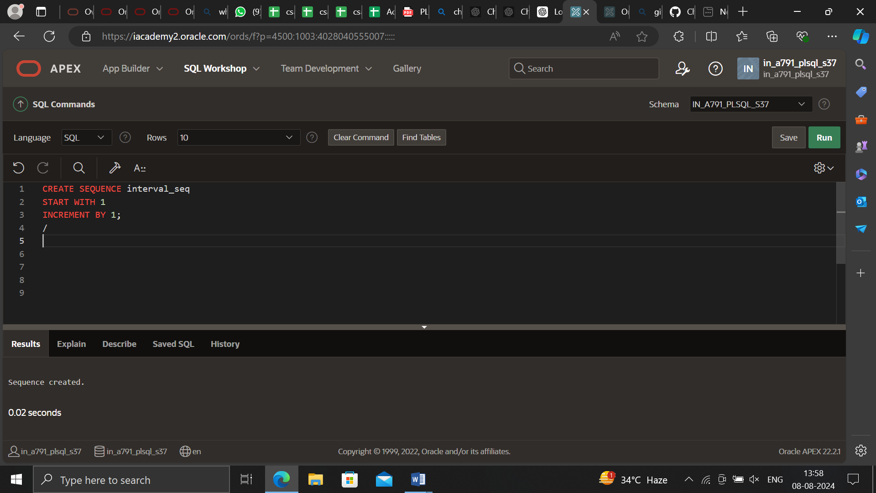

CREATE SEQUENCE interval_seq

START WITH 1

INCREMENT BY 1;

/

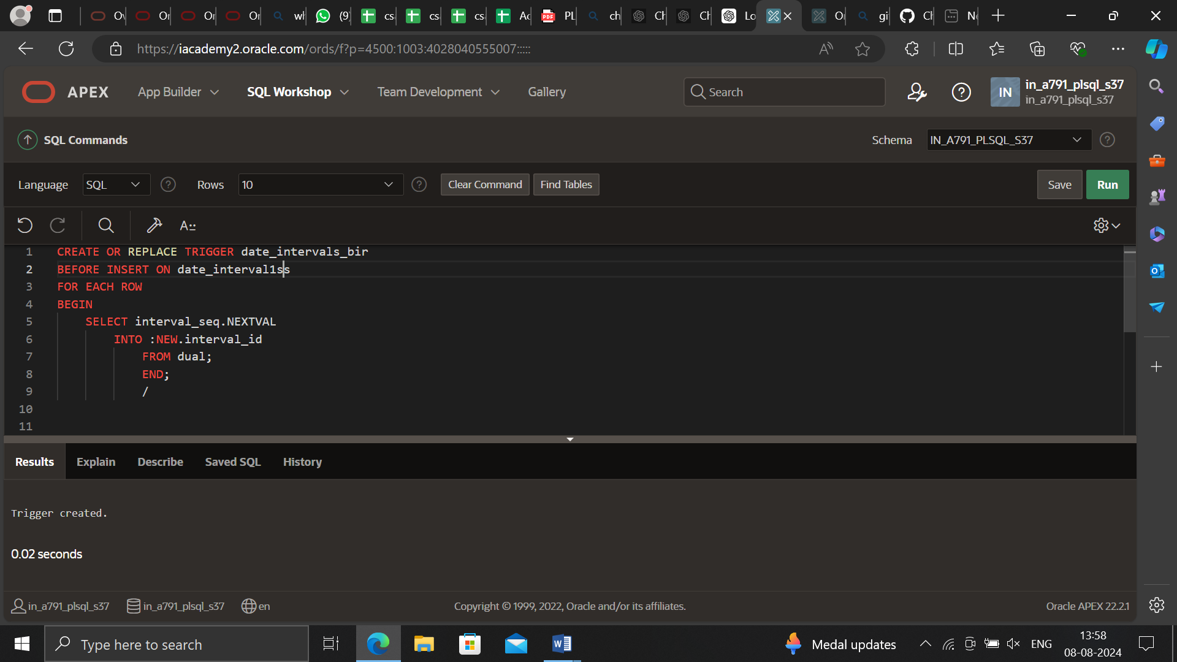

CREATE OR REPLACE TRIGGER date_intervals_bir

BEFORE INSERT ON date_intervals

FOR EACH ROW

BEGIN

SELECT interval_seq.NEXTVAL

INTO :NEW.interval_id

FROM dual;

END;

/

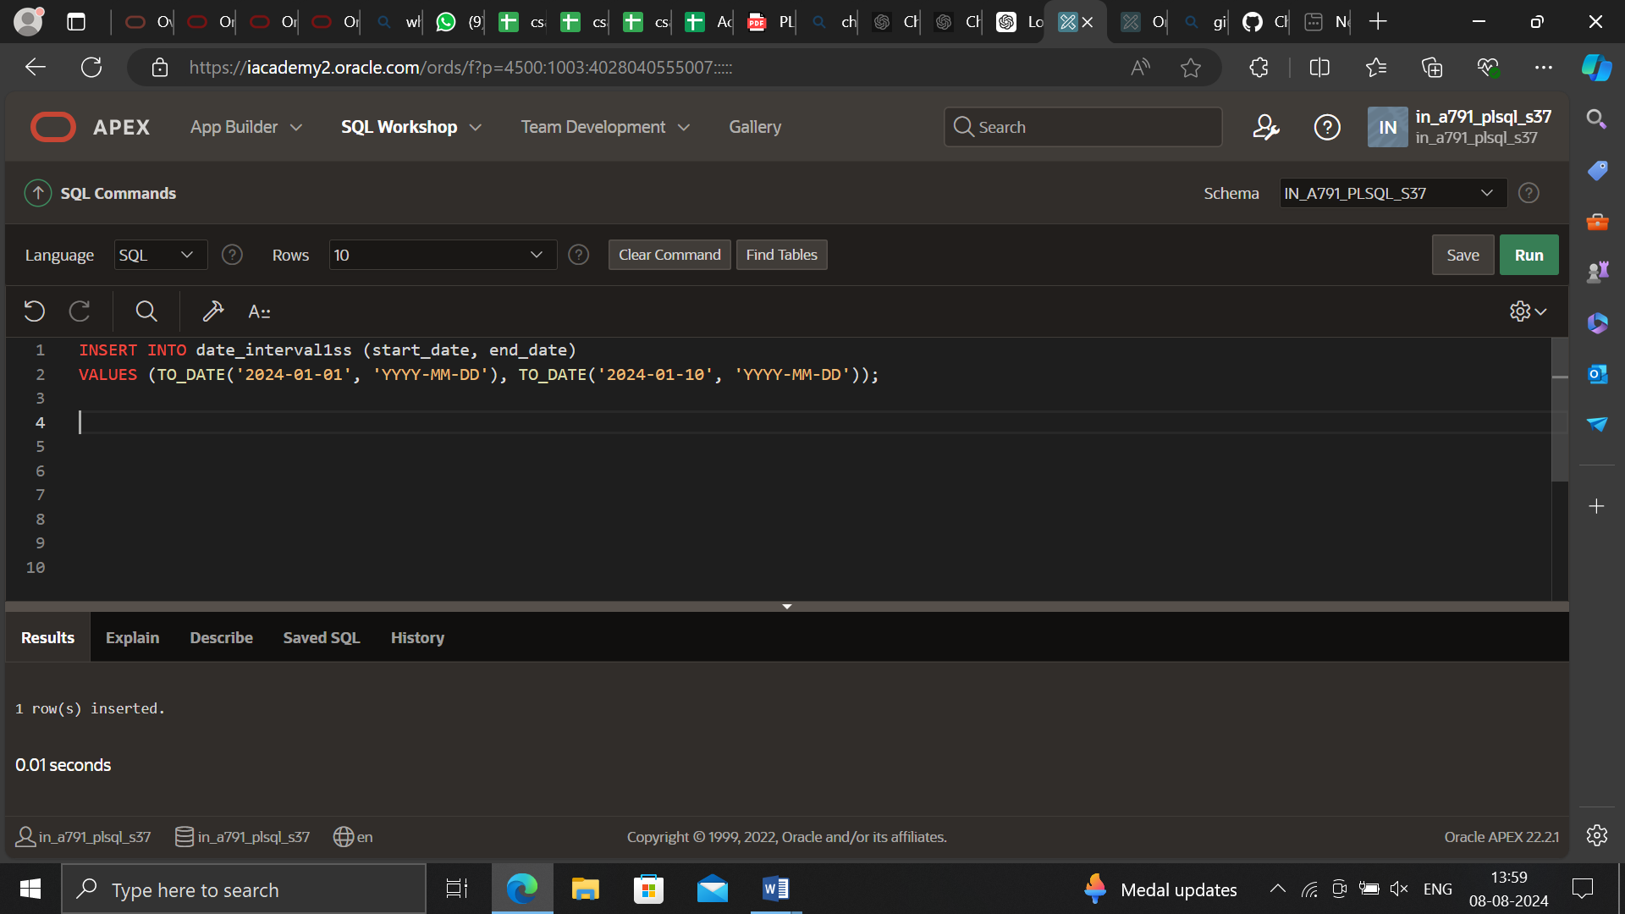

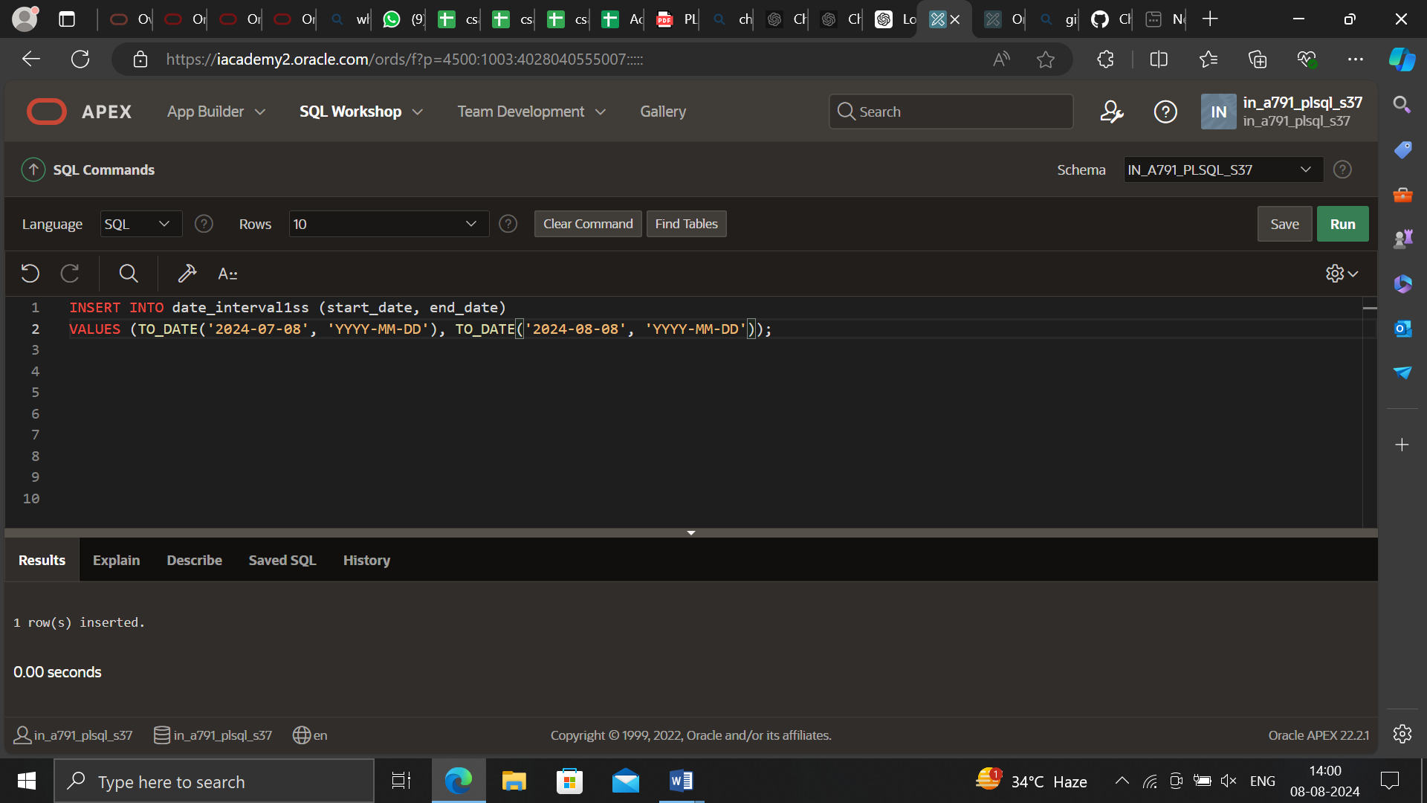

INSERT INTO date_intervals (start_date, end_date)

VALUES (TO_DATE('2024-01-01', 'YYYY-MM-DD'), TO_DATE('2024-01-10', 'YYYY-MM-DD'));

INSERT INTO date_intervals (start_date, end_date)

VALUES (TO_DATE('2024-02-01', 'YYYY-MM-DD'), TO_DATE('2024-02-15', 'YYYY-MM-DD'));

COMMIT;

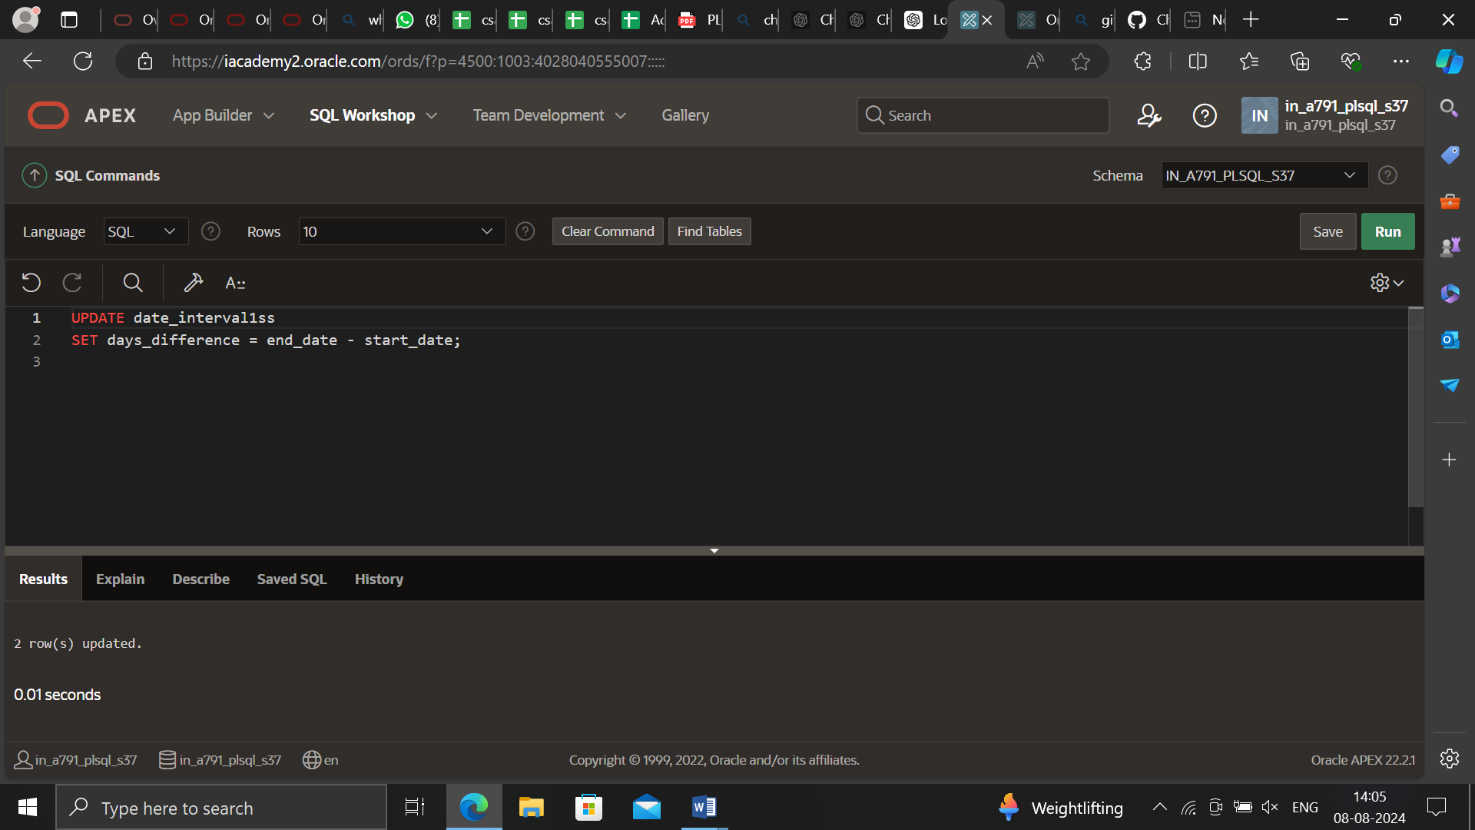

UPDATE date_intervals

SET days_difference = end_date - start_date;

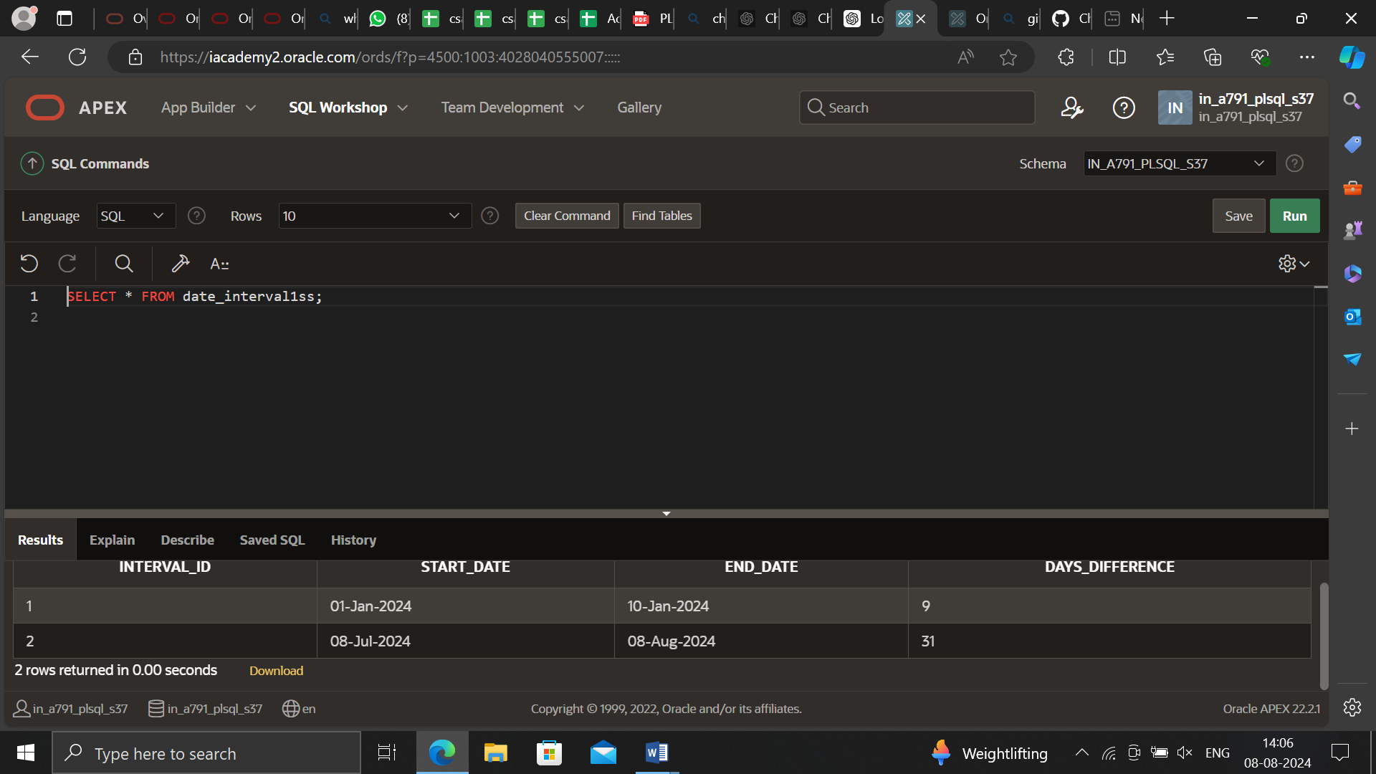

SELECT * FROM date_intervals;